# The COVID‐19 social media infodemic [>>](marginnote3app://note/7929EF37-26C9-476E-96D1-29C826CE495E)

## Introduction [>>](marginnote3app://note/51BB915D-0173-4155-AB0E-45144C6FF827)

### The definition of infodemic [>>](marginnote3app://note/4AF893CA-6A1C-4D78-B3B7-53F92F8864D6) has been coined to outline the perils of misinformation phenomena during the management of disease outbreaks5–7, since it could even speed up the epidemic process by influencing and fragmenting social response8

### The focus of this article [>>](marginnote3app://note/369F4476-78C0-430C-93DF-70CF8D39E8C1) Consequently, in this paper we perform a comparative analysis on five social media platforms (Twitter, Instagram

### Using R0 to measure the spread of infodemic of COVID-19, which is a good start. [>>](marginnote3app://note/1ECE2833-6E37-4E3E-B339-E21C04922A75) , characterizing for each platform its basic reproduction number ( R0 ), i.e. the average number of secondary cases (users that start posting about COVID-19) an “infectious” individual (an individual already posting on COVID-19) will create. In epidemiology, R0 = 1 is a threshold parameter. When R0< 1 the disease will die out in a finite period of time, while the disease will spread for R0> 1 . In social media, R0> 1 will indicate the possibility of an infodemic.

### How to classification of COVID-19 [>>](marginnote3app://note/08E3007E-FA28-4B42-8CFF-FA5D9E945925) classification provided by the fact-checking organization Media Bias/Fact Check34

## Results [>>](marginnote3app://note/1D87295A-985A-410C-8E05-D64EAC4C96AE)

### Interaction patterns [>>](marginnote3app://note/9EDF2CEB-D77C-478F-9B08-D991E7D542A8)

#### The interactions of COVID-19 on each platform. [>>](marginnote3app://note/2B939E3A-1F27-40DC-9A5B-5D314D74985F)

#### the topics related to the COVID-19 content [>>](marginnote3app://note/66EC6263-9E45-4601-AFB2-232708483622)

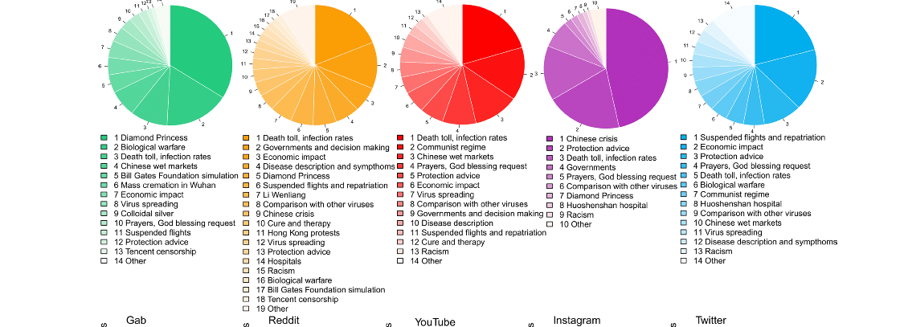

#### Information Spreading (R_0) [>>](marginnote3app://note/B8C0EA7E-1F9C-4D6A-ADE2-50ED692AF320)

### Questionable VS reliable information [>>](marginnote3app://note/C258F630-BFCA-416A-85CA-F0CFDF872620)

α = EU/ER .￼ It is a measure of whether a social media amplifies questionable ( α > 1 ) or reliable ( α < 1 ) posts.  
  


## Methods [>>](marginnote3app://note/83ECE306-D041-4B81-9D17-2CF420E2E9E9)

### Key words [>>](marginnote3app://note/2CAA4FBA-4218-4D41-830B-DCD0E09A863B)

#### coronavirus, pandemic, coronaoutbreak, china, wuhan, nCoV , IamNotAVirus, coronavirus_update, coronavirus_transmission, coronavirusnews, coronavirusoutbreak [>>](marginnote3app://note/74516BB4-7568-4F4E-9E6E-4D8F98F05F01)

### The Method of Category [>>](marginnote3app://note/64ADF7E6-A4EE-4C71-B871-5AB54AE3904E) Using such a classification, we assign to each of these outlets a binary label that partially stems from the labelling provided by MBFC. We divide the news outlets into Questionable and Reliable. All the outlets already classified as Questionable or belonging to the category Conspiracy-Pseudoscience are labelled as Questionable, the rest is labelled as Reliable.

# 文章发现的结果 [>>](marginnote3app://note/0E3561DC-7B8F-40B2-B0E0-B202E62F236F) However, information from both reliable and questionable sources do not present different spreading patterns.

不同的平台间并没有呈现不同，最终呈现的结果是基于不同的平名而实现的。  
这篇文章将疾病传播学的理论应用到infodemic的研究中。是一个全新的hi视角，将infodemic 与疾病传播学进行连接

# Matching ability [>>](marginnote3app://note/0B5AE804-0019-4B59-9E44-B8CA420A2FCF)

# the Partitioning Around Medoids (PAM) algorithm [>>](marginnote3app://note/3FBE5FFC-DC71-4427-9D9C-F53139AC01C3)

# classical SIR model44 [>>](marginnote3app://note/5C7B6827-7659-4455-9FC1-632AE5C623B0)